ORCID USER GUIDE
Step 1:
Loading a file and setting up image parameters
During this step, refer to Step 1.A to check your work.

Load an image file by clicking the “Load Image File” button at the top of the parameters panel. You may load any of the following:
Tagged Image File Format (.tiff), Graphics Interchange Format (.gif), Portable Network Graphic (.png), JPEG (.jpg), Bitmap (.bmp)
The Tagged Image File format is highly recommended for analysis.

Adjust the threshold:
For most images, the default filter radii settings should be adequate for feature identification. Tweaking these parameters should take place after setting an appropriate threshold. Below is a file format-specific list of recommended thresholds:
.tiff (multi-tiff or single frame) – Threshold: 0.9
.gif (animated or single frame) – Threshold: 0.05-0.1
.png – Threshold: 0.05-0.5
.jpg – Threshold: 0.03-0.2
.bmp – Threshold: 0.05-1.0

These thresholds should be adequate for most images, but make sure to adjust the threshold so that all of what you see with your eye is preserved. Having a threshold that is too high will give an image with many missing features, or no features at all. Having a threshold that is too low will give an image that highlights dark features that are barely visible to the naked eye.

Set the Region of interest This is important if you have multiple cells in one image but only want to analyze one of them. BE GENEROUS with your region of interest. Select the largest region that you can without including other cells, then right click the image and select “create mask” to create a region of interest. (applies to all frames)

If your images still have misidentifications in them, it may be necessary to adjust the filter radii. Check the troubleshooting guide below.

Troubleshoot:
- Artifact clusters (clusters that do not correspond to anything in the image) appear in large empty regions, usually repeating structures or wave-like features
  - Upper filter radius should be increased
    - OR: Threshold should be increased
  - Edge removal should be enabled, even if edge removal is set to zero microns.
- Features are too smooth or bleed into each other
  - Distance between upper and lower filter is too small. Either increase the upper filter or decrease the lower filter.
- Many tiny noise-like features
  - Increase the lower filter radius
    - OR: Increase the threshold.
Step 1.A:
Checking your Parameters as you go

It isn't always easy to check If your parameters are working properly. If you want a quick preview of the clusters any set of parameters will give you, click on the “Filtered, Thresholded image” radio button. Compare this with the “Original Image” radio button to see if your filter is working (highlighted features match what you see). If it's not working, look at “Filtered Image” to see what sort of artifacts are being generated, and if your filter is failing because of threshold values, or upper/lower filter radius.

Step 2:
Identifying Clusters

Identifying clusters is easy once you set up your filter. Simply click the “Identify Clusters” button. If you want to have special graphing colors depending on certain aspects of your clusters, you can assign special plotting options to each color channel. For example, if you wanted your biggest clusters to be red and the smallest ones to be black, you would set “Red channel” to “Area” and set the other two channels to “off”. If you wanted your most eccentric clusters to be yellow and your least eccentric clusters to be green, set “Red Channel” to “Eccentricity”, set ”Green Channel” to “on” and set “Blue Channel” to “off”. There are many more possible combinations, and random is the default color setting for each channel. Check the “Auto-ID” button if you want the clusters to be re-identified every time you change something (Warning! This can be pretty slow if you are changing parameters or frames frequently).

Step 3:
Interpreting and Exporting Data

ORCID returns a large quantity of data from each image analysis, so understanding the output is extremely important. The first type of data you will encounter is the graphical data displayed in the main plotting window. It consists of convex polygons outlining each cluster identified by the program. A convex polygon will not conform to concave cluster features to reduce the load on the computer's CPU, which is sort of like wrapping a rubber band around the cluster. Do not confuse this outline with the actual cluster pixels themselves, which can be viewed by selecting the “Filtered, Thresholded image” graphing option outlined in step 1.A.

The second data output type is the tabulated data in the lower left hand corner of the window. This is the numerical data that classifies each cluster (rows) by different parameters (columns). Currently there are fields for Eccentricity, Orientation, Mean Pixel value, Area, Perimeter, and ID number, where the ID number is simply a tag to keep track of each cluster throughout the analysis process.

When rows are highlighted in the tabulated data window, the corresponding clusters will be drawn individually in the preview window (upper right). You may select individual or multiple clusters to generate graphics corresponding to data points of interest. Be warned that selecting clusters by dragging the cursor across many data points will re-render each cluster every time a cell is added, so be prepared for program slowdown while selecting an indeterminate number of clusters. To avoid such slowdown, select individual clusters by control-clicking cells, or select groups by shift-clicking on cells.

Tabulated data may be exported by clicking the “Export data” button, which generates a Microsoft spreadsheet document (If Microsoft office is not available, a generic spreadsheet document is generated.) Cells may also be copied individually from the program window into Microsoft office. Exported data also contains some additional information that can be calculated from the individual cluster data. Along with information about each cluster, the program outputs average data for the entire cell along with the standard deviations of that data.

Three dimensional Analysis:

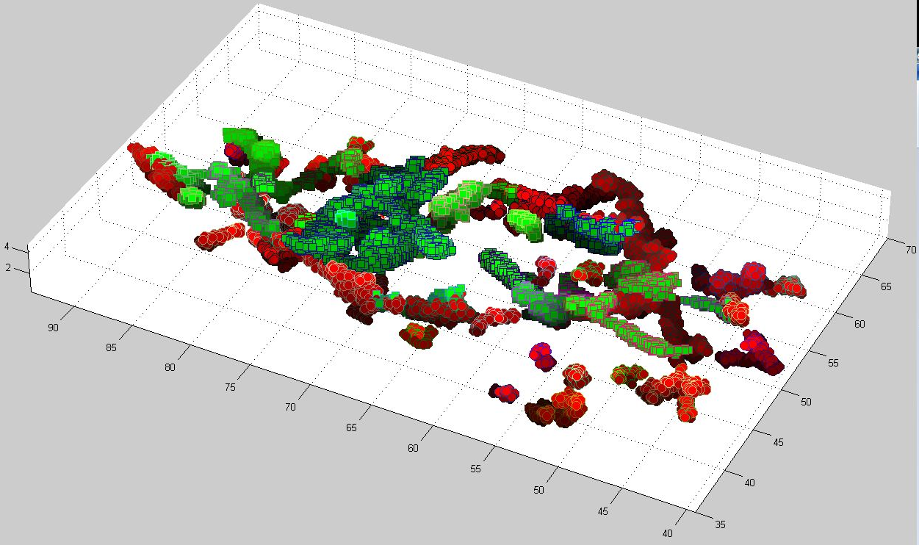
ORCID has built-in functionality for generating 3D data from a multiple frame image. Once the image is loaded, you may select either “Plain Stack” to get a quick overview of cluster morphology, or “Z-correlation” to get a detailed, parametrized analysis of voxel neighborhoods in the stacked image. When selecting “Plain Stack” be sure to specify a frame range that you wish to render. When selecting “Z-correlation” the program will prompt you for the number of species, and frame ranges for each species to identify within the image. Multi-species analysis is based on multiple frame tiff images in which each channel is separated into its own frame stack, so a 20 frame RGB image would actually contain 60 frames of gray-scale image data. ORCID treats each cluster in the first range of frames as species one (green) and each cluster in the second range of frames as species two (red). There is currently no support for more than two species.

Data output for three dimensional analysis is very similar to the two dimensional output. The user is presented with graphical and tabulated data. An example of the graphical data is shown here. Each species can be clearly identified by the green and red coloring, and each cluster within each species can be identified by the uniquely colored borders on each data point.

